**Project Report On**



HEALTHIFY

Centralized Healthcare Management System

Submitted in partial fulfillment for the award of

**Diploma in Advance Computing(E-DAC) from C-DAC, ACTS (Pune)**

**Guided by:**

**Mr. Shakir H.**

**Presented by:**

**Mr. Surya Saini PRN Number 210540181207**

**Mr. Naval Gazta PRN Number 210540181115**

**Mr. Sourabh Mahamuni PRN Number 210540181100 Ms. Akshata Sawant PRN Number 210540181181 Ms. Sayali Torase PRN Number 210540181182**

**Centre for Development of Advanced Computing (C-DAC), Pune**

**ACKNOWLEDGEMENT**

On the very outset of this report we would like to extend our sincere and heartfelt obligation to all the personages in this endeavor. Without their active guidance, help, cooperation and encouragement we would not have been able to complete this project.

This project “**Healthify**” was a great learning experience for us and we are submitting this work to Advanced Computing Training School (CDAC ACTS). We would like to express our sincere gratitude to our mentor *Mr. Shakir H* for his valuable guidance during this project. His guidance and support helped us to overcome various obstacles and fuelled our minds to finish the project.

We are highly grateful to *Ms. Risha P.R.* (Manager ACTS training Centre), C-DAC, for her guidance and support whenever necessary while doing this course Diploma in *Advanced Computing (E-DAC)* through C-DAC ACTS, Pune.

Our heartfelt thanks goes to *Ms. Swati Salunkhe* (Course Coordinator, E-*DAC*) who gave all the required support and kind coordination to provide all the necessities and extra hours to complete the project and throughout the course up to the last day here in C-DAC ACTS, Pune.

Mr. Surya Saini (200940181207)

Mr. Sourabh Mahamuni (200940181100)

Mr. Naval Gazta (200940181115)

Ms. Akshata Sawant (200940181181)

Ms. Sayali Torase (200940181182)

# TABLE OF CONTENTS

1. Introduction of Project
2. Product Overview and Summary
   1. Purpose
   2. Scope
   3. Overview
   4. Feasibility Study
3. Overall Description
   1. Product Feature
   2. Technology Used
   3. User Classes

3.3 General Constraints

1. Requirement
   1. Functional Requirements
   2. User Interface Requirements
2. Design
   1. Database Design
3. Project Testing
4. Project Management Methodology
5. Future Scope
6. **INTRODUCTION :**

Healthify is a system which manages patient’s medical history on centralized platform to make it easy for doctors as well as patients to view their medical history for further reference.

Users can view their medical information conveniently as well as some other informations like Covid-19 tracker, which displays current situation in India about covid spread. User Interface, developed in React uses user email to authenticate and data is imported using REST. UI makes secure calls to Spring Boot. In the backend, JAVA is used to fetch and manipulate the data and used MySQL as database.

The Healthify also provide facility to view and read some health related blogs . Healthify provides facilities to doctor to add their consultations, assigned medication, future prognosis about a patient. The application also allows user to view list of doctors in particular city according to required specification.

For all this a lot of APIs are used for the ease of user. API allows two applications to talk to each other and then the application interprets that data and presents the user with the information the user wanted in a readable way.

For the login of users into this website we use the user email authentication. To sign up into the platform user have to provide multiple information like Aadhar no., name, email, password, DoB, etc. And for doctors, there is additional information asked about experience and qualification, Registration ID, etc. This platform is based on REST services and it tends to independency of all services. This platform is rapid and frequent due to this technique.

1. **PRODUCT OVERVIEW AND SUMMARY**
   1. **Purpose:**

In general scenario we don’t have any centralized system which can manage patient’s data. Its hard for the patients to carry papers about their previous consultations and medications every-time they go to the doctor. Especially when any patient needs to go to another doctor for consultation, patient have to carry all the documents in paper format and its difficult for doctors too to go through them and then give further treatment especially in serious cases.

We needed a system which can manage all this data centrally which can be accessed by any doctor using patient’s unique ID.

* 1. **Scope:**

Healthify is an application which manages health related information of patients and doctors can consult them on the same platform.

* 1. **Overview:**

Section 3.0, the Overall Description, provides an overview of the components and the relationship between them. Section 4.0 provides the Specific Requirements of the product. In the subsection (4.1) and (4.2) of which the various functional requirements and various interface respectively are discussed. Section 5.0 describes Database Design details.

* 1. **Feasibility Study**

Feasibility is determination of whether a projects worth doing or not. Before actually recommending the new system, it is important to investigate if it is feasible to develop the new system.Before developing and implementing a system we have sure that our system is feasible in the following ways.

* **Technical Feasibility:**

In the type of feasibility study, the system analyst has to check whether it is possible or not to develop the requested system with availability of manpower, software, hardware, etc. The system runs on Linux as well as windows platform and hence are suitable for the end- user. The system is technically feasible because it does not require too many resources and runs with the browser. A proof of concept was implemented to verify the technical feasibility to retrieve data from various APIs.

* **Operational Feasibility:**

In this type of feasibility study the operation implementation of the system is considered. Checking is done regarding whether it is feasible for the users to use the application. Thus, the proposed system is said to be operationally feasible. Users can use the system with ease and with the minimum training.

1. **OVERALL DESCRIPTION:**
   1. **Product Features**

The project's aim is to provide a centralized healthcare system.

System contains Java, Spring Boot, ReactJS, Spring Data, MySQL as developing technologies.

* 1. **Technologies Implemented**

**Back End**

Spring Boot, Hibernate.

Spring Data and MYSQL (As Database)

# Front End

ReactJS

Bootstrap

CSS

**J2EE Spring Boot**

Spring Boot has been built for Rapid Application Development. The goal of Spring Boot is to

provide a way to create Java applications quickly and simply, through an embedded server. By default, it used an embedded version of Tomcat and hence eliminating the need of Java EE containers.

It is a framework to ease the bootstrapping and development of new Spring Applications. Bootstrapping with defaults included in the configuration/ jar-dependencies. Easy to create standalone applications with embedded Tomcat/Jetty/Undertow. It provides defaults for code and annotation configuration to quick start new spring projects within no time. Plenty of Spring Boot Starter to quickly get up and running.

No code generation and no requirement for XML configuration. It reduces lots of development time and increases productivity.

**React**

React is a JavaScript library for building user interfaces. It has transformed the way we think about front-end development. React.js has clasped the engagement of the open-source community. And its demand is irreversible in the coming future. It is here to stay.

Improved performance: React uses Virtual DOM, thereby creating web applications faster. Virtual DOM compares the components’ previous states and updates only the items in the Real DOM that were changed, instead of updating all of the components again, as conventional web applications do.

**MySQL**

MySQL is an open-source relational database management system (RDBMS).A list of commonly used MySQL queries to create database, use database, create table, insert record, update record, delete record, select record, truncate table and drop table etc. MySQL is a relational database management system based on SQL – Structured Query Language. The application is used for a wide range of purposes, including data warehousing, e-commerce, and logging applications.

The most common use for MySQL, however, is for the purpose of a web database. It can be used to store anything from a single record of information to an entire inventory of available products for an online store. In association with a scripting language such as PHP or Perl (both offered on our hosting accounts) it is possible to create websites which will interact in real- time with a MySQL database to rapidly display categorized and searchable information to a website user.

* 1. **User Classes**

There are three type of users which can access this website. One is patient, the second one is doctors, and Admin which will manage the users.

* 1. **General Constraints**

Users should have an email and a browser.

# REQUIREMENTS

* 1. **FUNCTIONAL REQUIREMENTS**

**Overall System:**

# USER

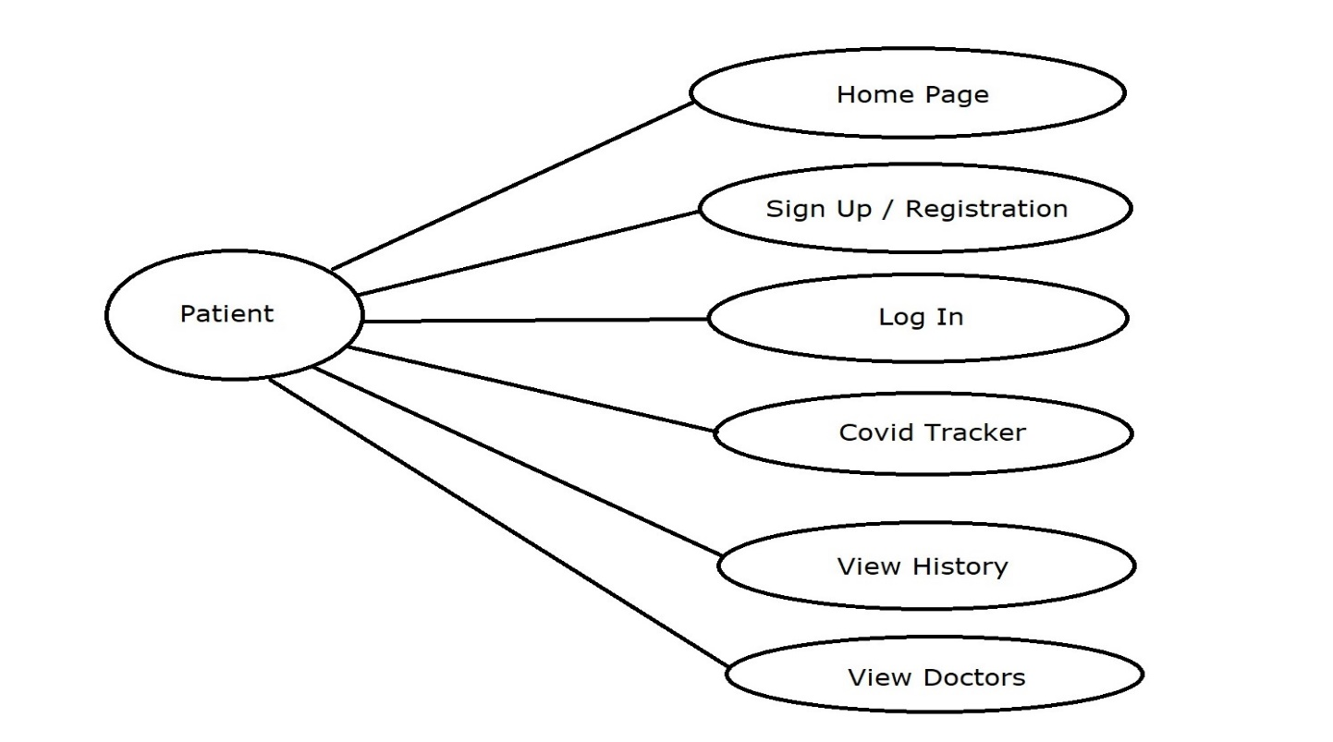

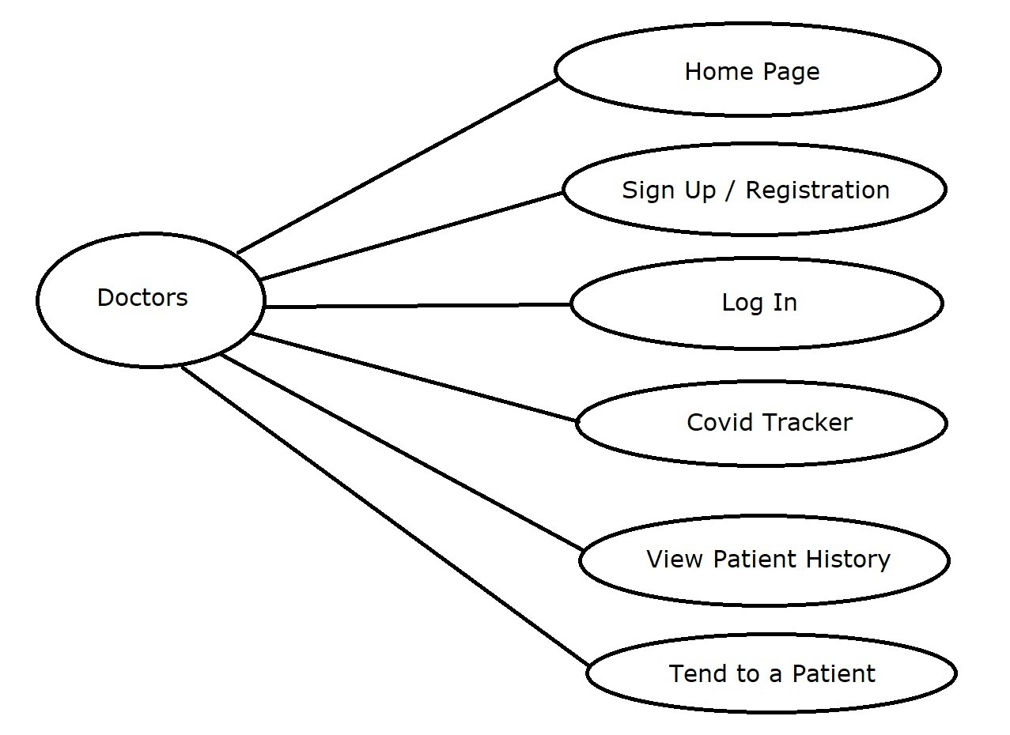

**4.2 USER INTERFACE REQUIREMENTS**

**Home Page**

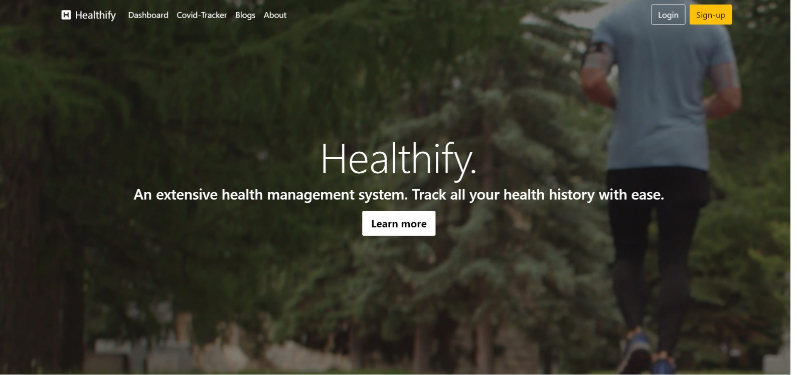

**Login Page :**

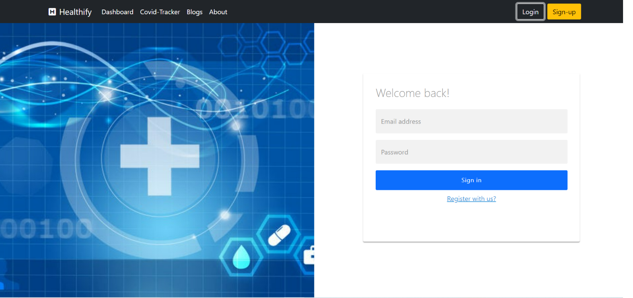

**Patient Registration :**

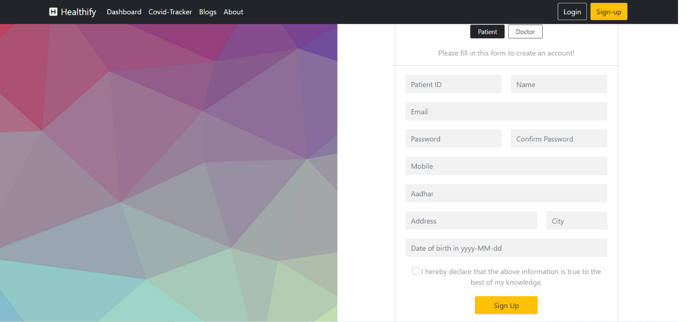

**Doctor Registration :**

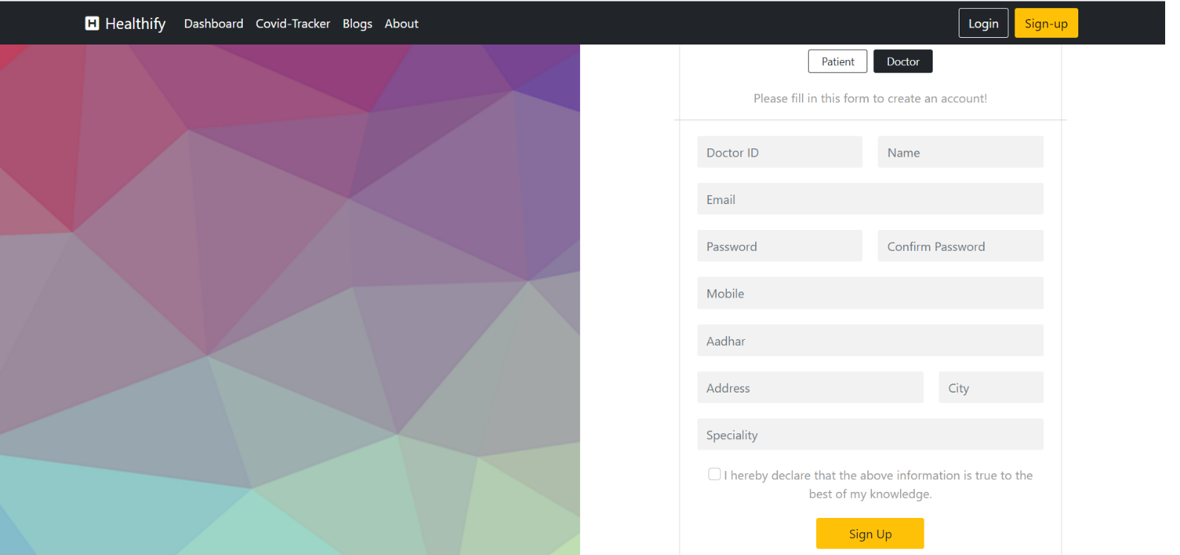

**Doctor’s Page :**

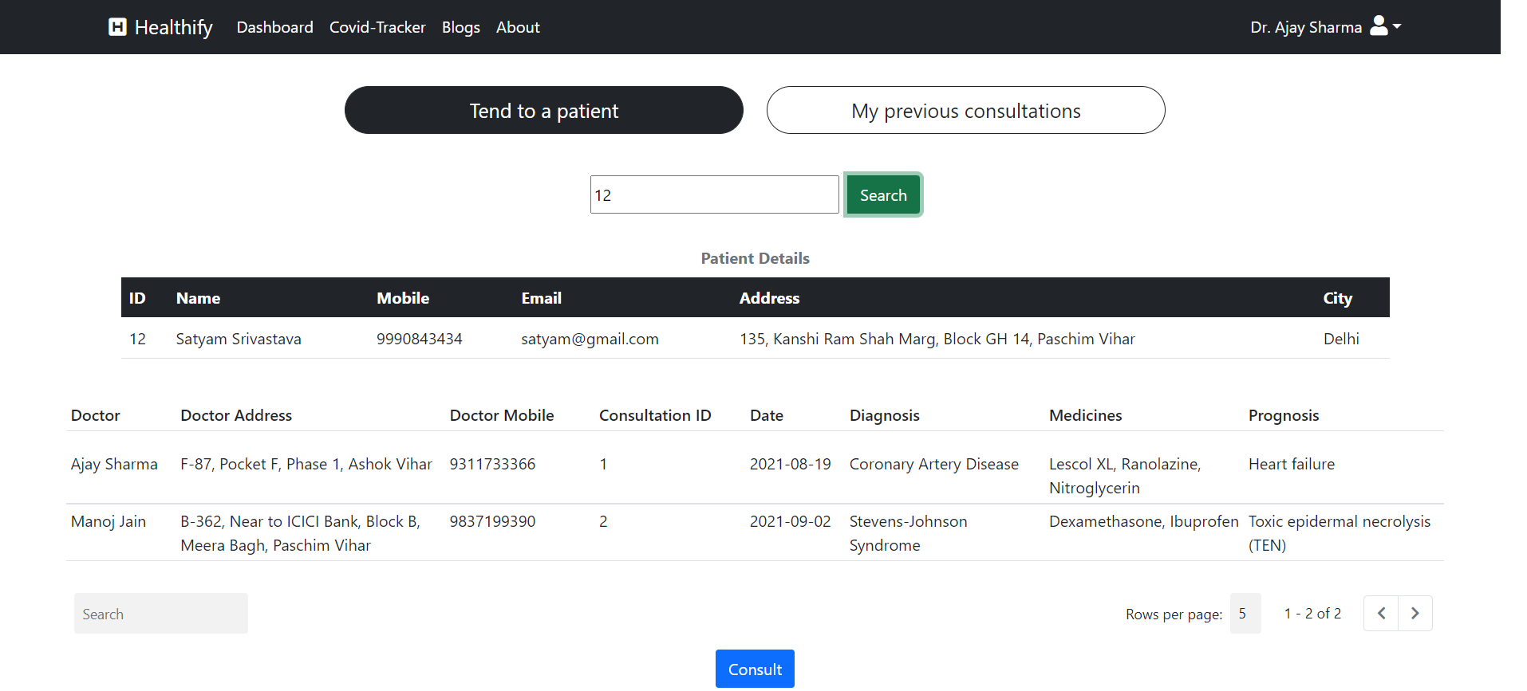

**Doctor’s Previous Consultations :**

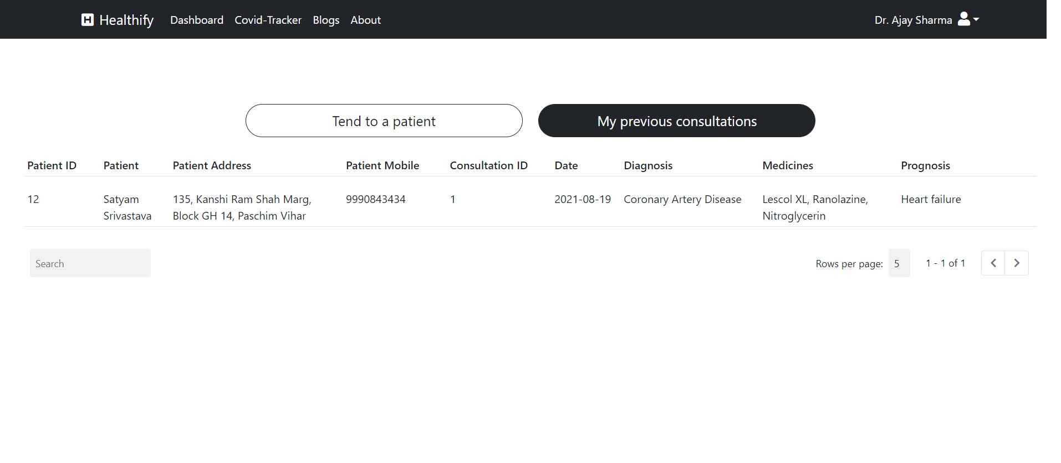

**Patient’s Homepage :**

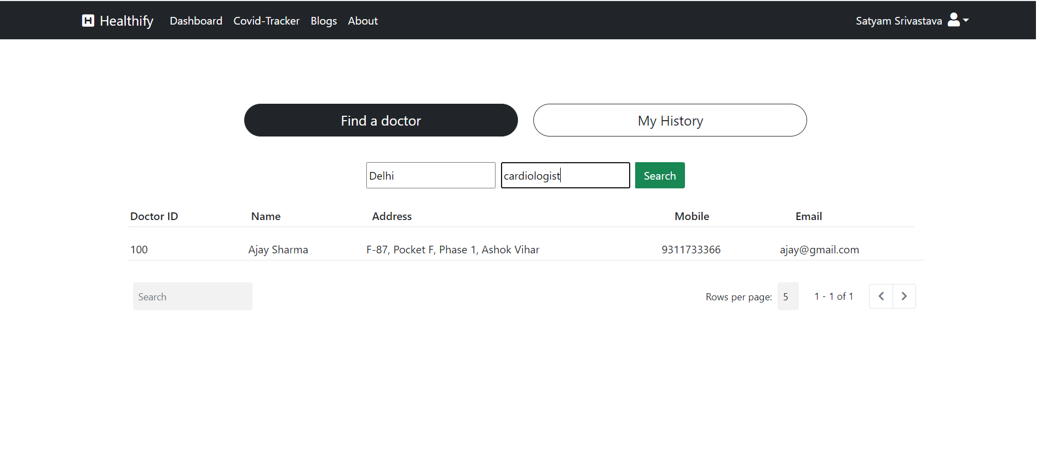

**Patient’s Homepage (History) :**

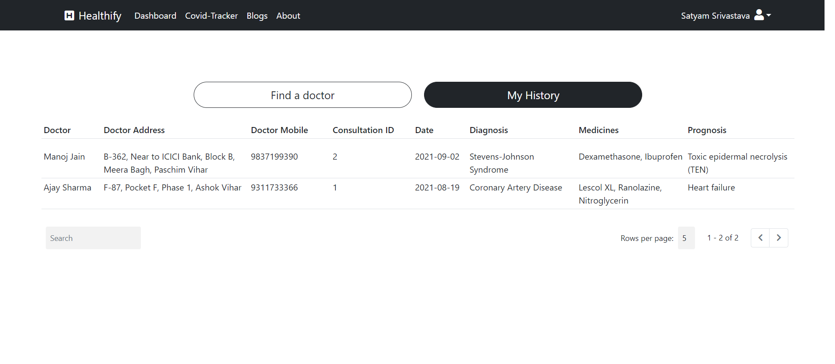

**Covid Tracker :**

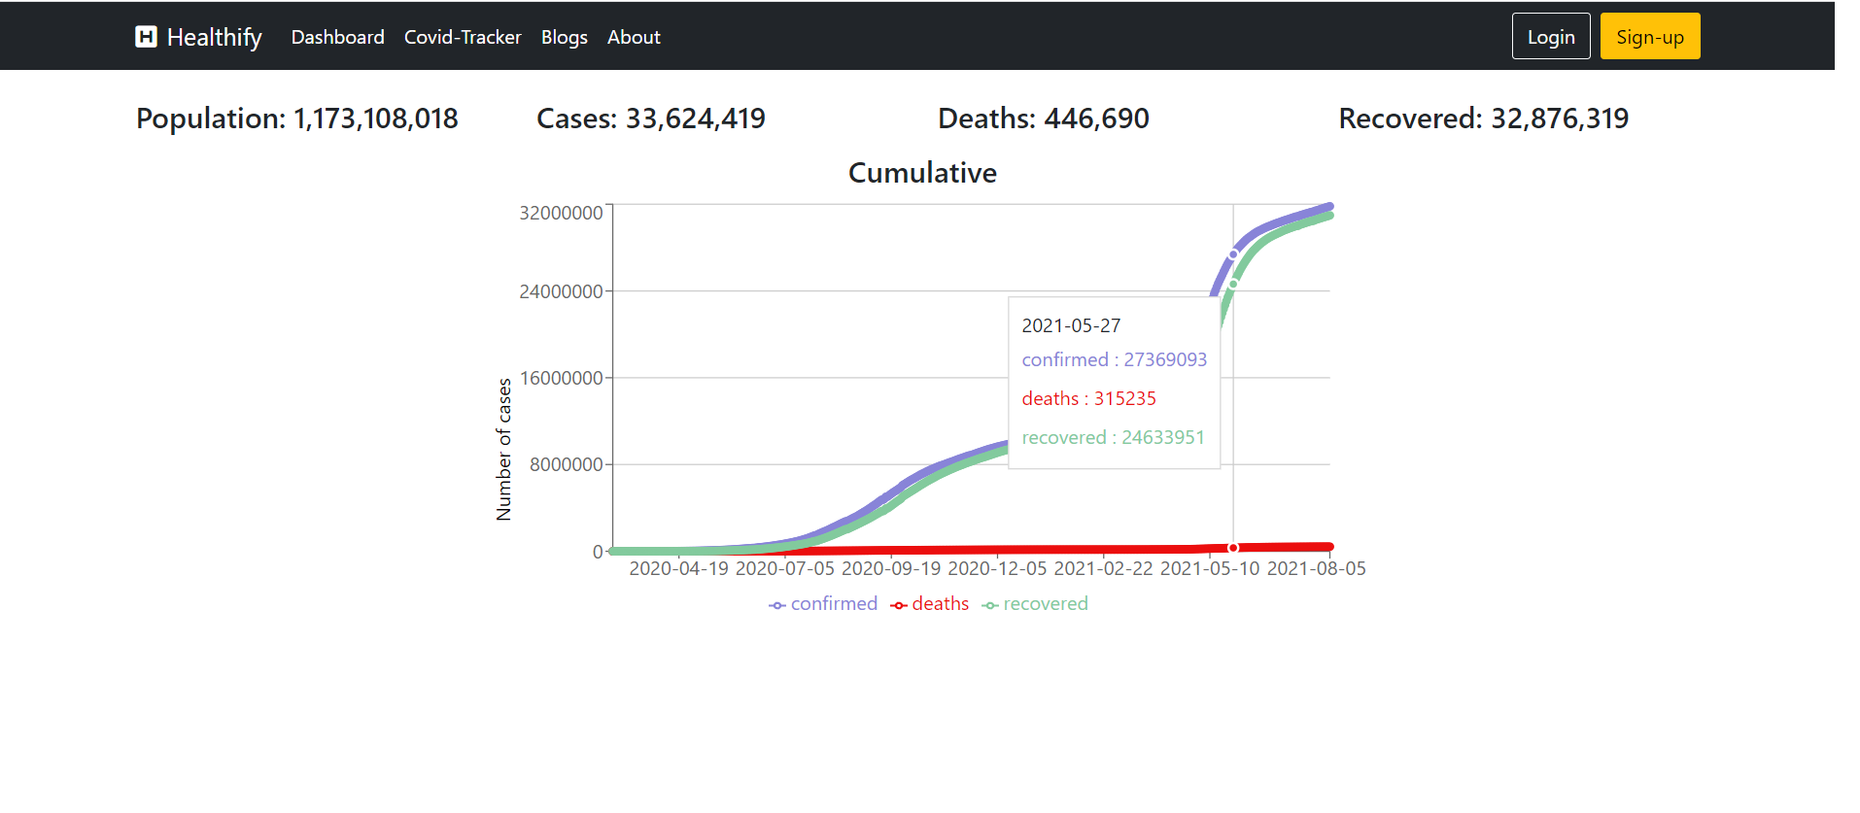

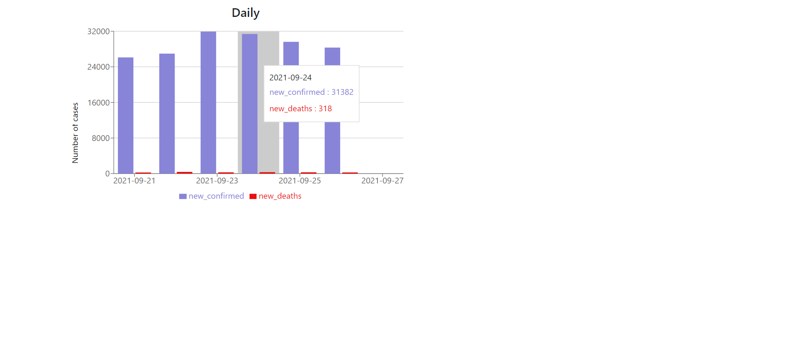

**About Us Page :**

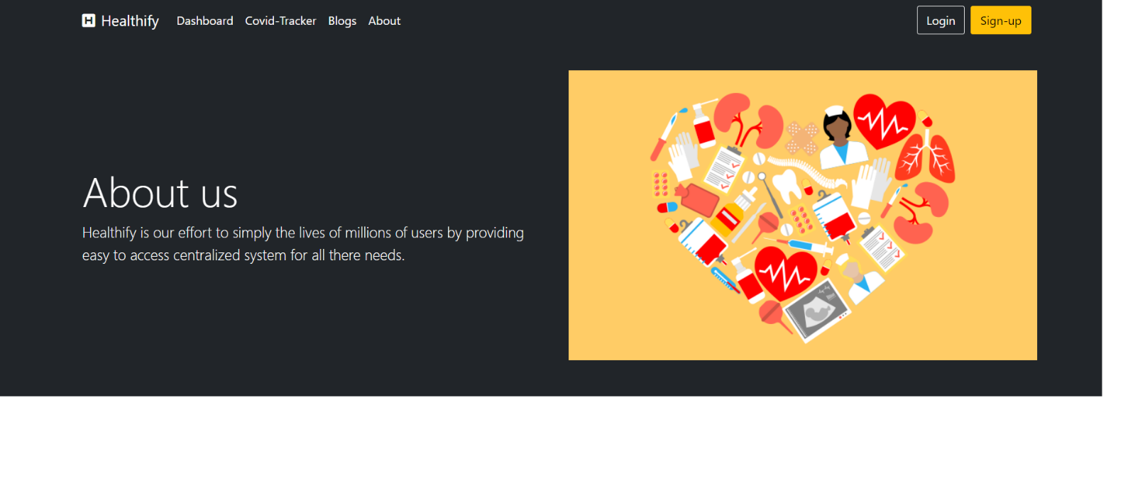

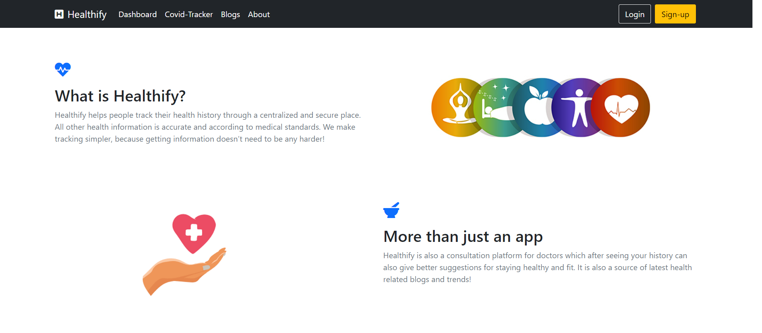

# DESIGN

**5.1 Database Design**

The following table structures depict the database design.

**ER Diagram :**

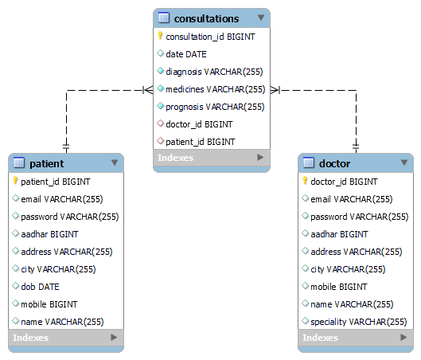

# PROJECT TESTING

The report of the testing is given as under

**Test Cases**

|  |  |  |  |  |  |
| --- | --- | --- | --- | --- | --- |
| **Sr.**  **No** | **Test Case**  **Title** | **Description** | **Expected**  **Outcome** | **Error**  **Message** | **Result** |
| 1 | Login Page | User should login to system after entering email and password. | After signing in user to be directed to dashboard. | Invalid  Login | Passed |
| 2 | Dashboard  Displayed | Dashboard page display for every successful log in. | Dashboard page  Displayed | No Error | Passed |
| 3 | Register | Users should be able to register as patient or doctor. | User should be registered successfully. | No Error | Passed |
| 4 | Previous Consultations | Doctor should able to see previously given consultations. | Consultations in tabular format | No Error | Passed |
| 5 | Tend to a patient | Doctor should see patient’s history by inserting patient’s ID. | Patient’s history in tabular format | No Error | Passed |
| 6 | Consult | Doctor should get a form to enter consultation | A form to insert consultations by doctor | No Error | Passed |
| 7 | Find a doctor | Patient should be able to search doctor according to city and speciality. | A dropdown to select city and speciality | No Error. | Passed |
| 8 | View my history | Patient should be able to see its medical history. | List of previous history in tabular format. | No error | Passed |
| 9 | Sign Out | User should be able to logout from the website | User will logout and will be redirected to the Home page. | No Error | Passed |

# PROJECT MANAGEMENT METHODOLOGY

Scrum Agile Methodology was used.

# 8. FUTURE SCOPE

* 1. We can add appointment booking option for consultations with a doctor.
  2. We can add online consultations by doctors for distant patients.
  3. We can add provision to see availability of facilities like beds and oxygen cylinder in nearby hospitals.
  4. We can provide more options for the patient to make thi